Team Id: NM2025TMID14999

Team Members: 4

Team Leader: Aadhitya E

Team Member 1: Jeyasurya S

Team Member 2:Sridhar K

Team Member 3:Ravibharathi P

**Problem Statement:**

In a small project management team consisting of a Project Manager (Alice) and a Team Member (Bob), there is a need to efficiently manage project tasks and ensure accountability throughout the project lifecycle. The current system lacks clear role definitions, access controls, and a structured workflow, leading to confusion regarding task assignments and progress tracking.

**✅ Steps to Create a New User in ServiceNow**

1. **Log in to ServiceNow.**
2. In the left-hand navigation pane, click **“All”** to expand the list of available modules.
3. In the filter navigator (search bar), type **"Users"**.
4. Under the **System Security** section, click on **"Users"**.
5. In the Users list view, click the **“New”** button (usually found at the top of the page).
6. A form will open — fill in the required user details such as:
   * **First Name**
   * **Last Name**
   * **User ID**
   * **Email**
   * **Password** (if applicable)
   * Any other mandatory fields depending on your organization’s setup
7. Once all necessary information is entered, click **“Submit”** to create the user.

**➕ Create Another User in ServiceNow**

1. While still on the **Users** page, click the **“New”** button again to create a second user.
2. Fill in the user details as required. For example:
   * **First Name:** (Enter the user's first name)
   * **Last Name:** (Enter the user's last name)
   * **User ID:** (Choose a unique user ID)
   * **Email:** (Enter the user’s email address)
   * **Password:** (if applicable)
   * Any other required fields
3. After entering the information, click **“Submit”** to save and create the new user.

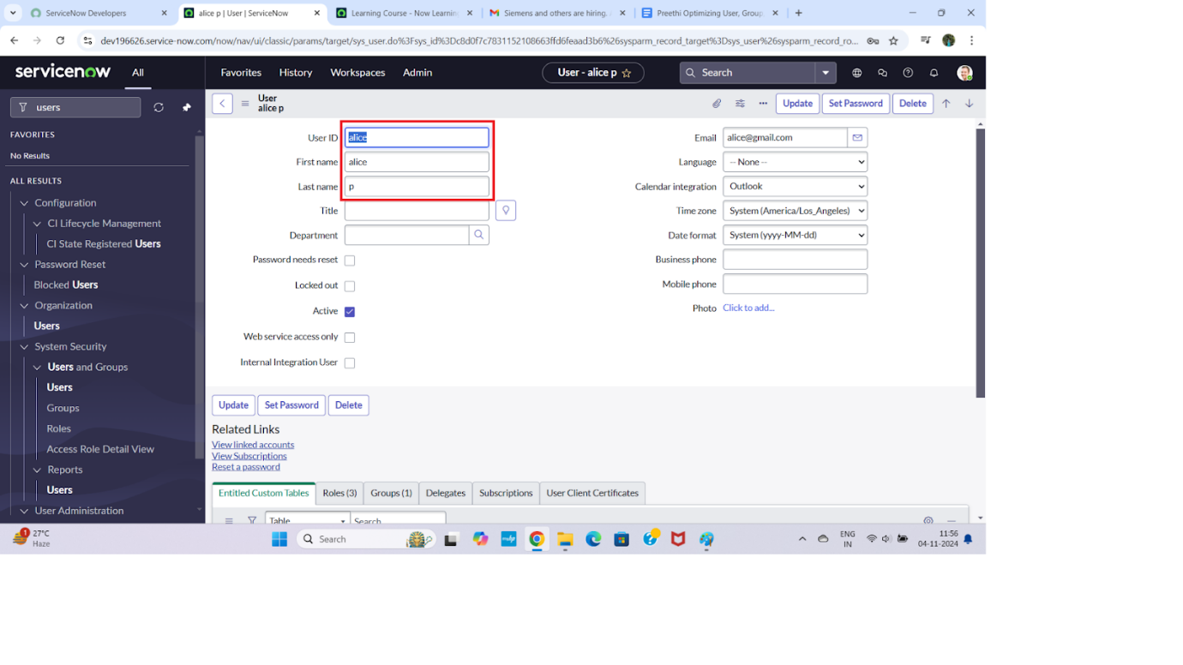

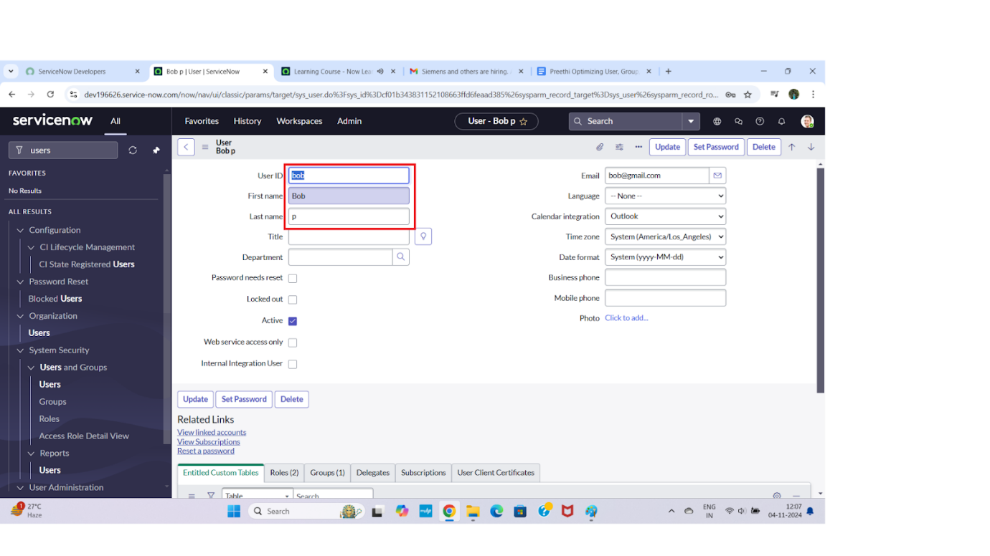

**✅ Steps to Create a New Group in ServiceNow**

**1.Log in to ServiceNow.**

2.In the left-hand navigation panel, click **"All"** to expand the list of modules.

3.In the filter navigator (search bar), type **"Groups"**.

4.Under the **System Security** section, click on **"Groups"**.

5.On the Groups list page, click the **“New”** button to create a new group.

6.Fill in the necessary group details, such as:

* + **Name** (e.g., "IT Support", "HR Team")
  + **Description** (optional but recommended)
  + Add **Users** to the group if required (using the related list at the bottom)

7.Once all required information is entered, click **“Submit”** to create the group

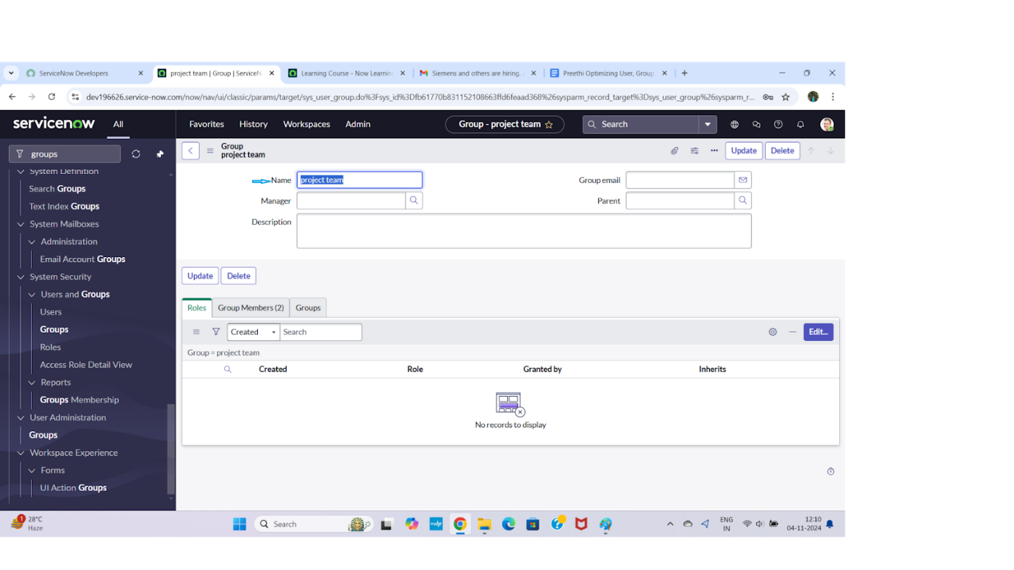

**🔐 Steps to Create a New Role in ServiceNow**

1. **Log in to ServiceNow.**
2. In the left-hand navigation pane, click on **"All"** to display the full list of modules.
3. In the filter navigator (search bar), type **"Roles"**.
4. Under the **System Security** section, click on **"Roles"**.
5. Once the Roles list page loads, click the **“New”** button at the top.
6. In the new role form, fill in the required details:
   * **Name** – A unique name for the role (e.g., it_admin, hr_viewer)
   * **Description** – (Optional) A brief description of what the role is for
   * Add any related permissions or modules, if needed
7. After filling out the form, click **“Submit”** to create the new role.

**➕ Create Another Role in ServiceNow**

8.To create another role, click the **“New”** button again on the **Roles** page.

9.Fill in the following details for the new role:

* + **Name:** team_member
  + **Description:** (Optional) A role for general team members

10.Once the information is entered, click **“Submit”** to save and create the new role.

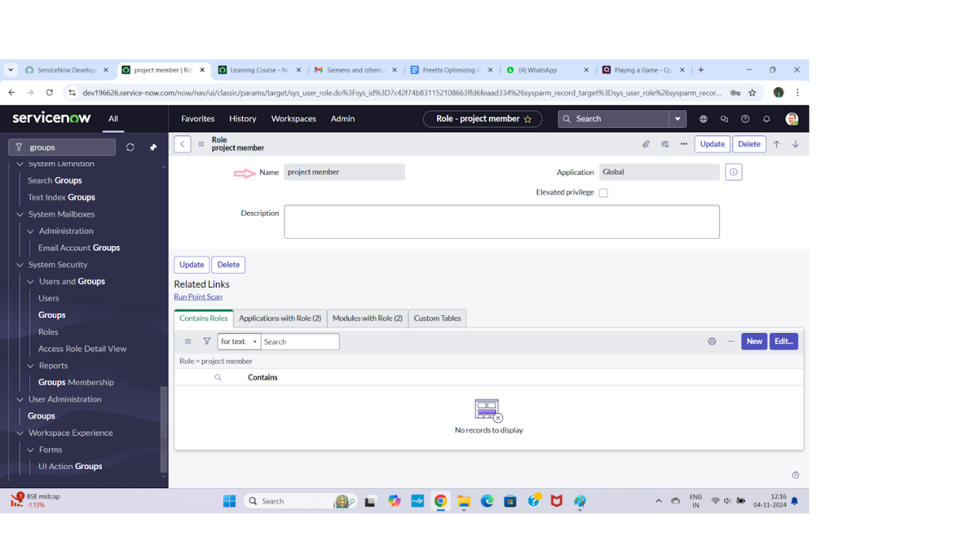

**📋 Steps to Create a New Table in ServiceNow**

1. **Log in to ServiceNow.**
2. In the left-hand navigation pane, click **"All"** to expand the full list of modules.
3. In the filter navigator (search bar), type **"Tables"**.
4. Under the **System Definition** section, click on **"Tables"**.
5. On the Tables list page, click the **“New”** button to create a new table.
6. In the **New Table** form, fill in the following details:
   * **Label:** Project Table
   * Check the boxes:
     + ✅ **Create module**
     + ✅ **Create mobile module**
   * **New menu name:** Project Table
7. Scroll down to the **Columns** section and add the fields/columns you want for the table.  
   For example:
   * **Name** – Type: *String*
   * **Start Date** – Type: *Date*
   * **End Date** – Type: *Date*
   * **Status** – Type: *Choice*
   * **Owner** – Type: *Reference* (referencing User table)
8. After entering all the necessary details and columns, click **“Submit”** to create the new table.
9. After you've added all the required details and table columns, go ahead and click the **“Submit”** button at the bottom of the form to save and create your new **Project Table**.

**➕ Create Another Table in ServiceNow**

1. Back on the **Tables** page, click the **“New”** button again to create a second table.
2. Fill in the details for the new table:

* **Label:** Task Table 2
* ✅ **Check** the boxes for:
  + **Create module**
  + **Create mobile module**
* **New menu name:** Task Table 2

1. In the **Columns** section, add the desired fields. For example:

* **Task Name** – Type: *String*
* **Assigned To** – Type: *Reference* (User table)
* **Priority** – Type: *Choice*
* **Due Date** – Type: *Date/Time*
* **Status** – Type: *Choice*

1. Once all fields are entered, click the **“Submit”** button to save and create the table.

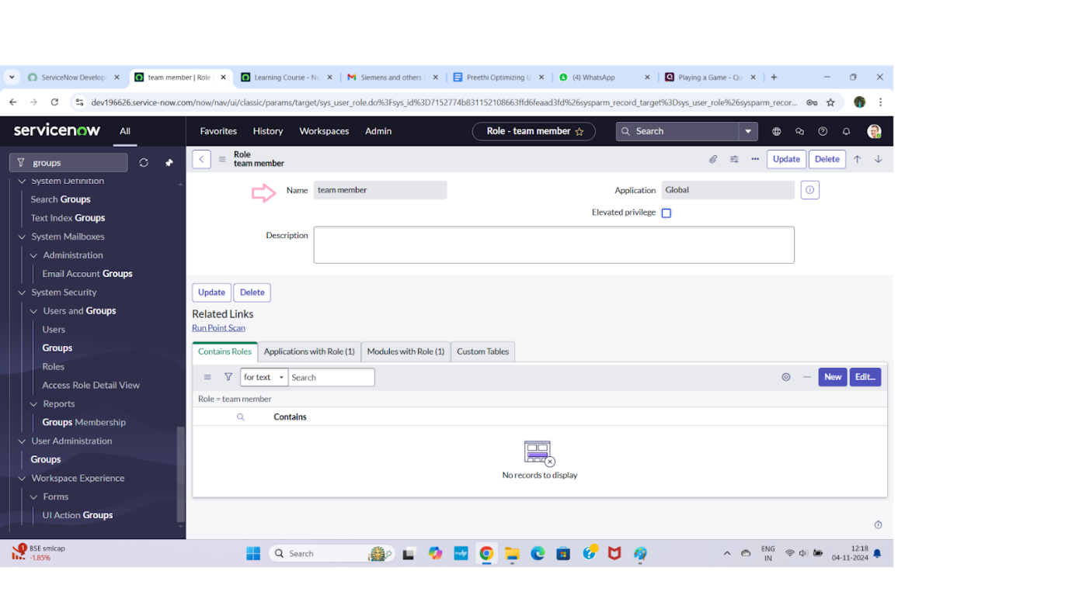

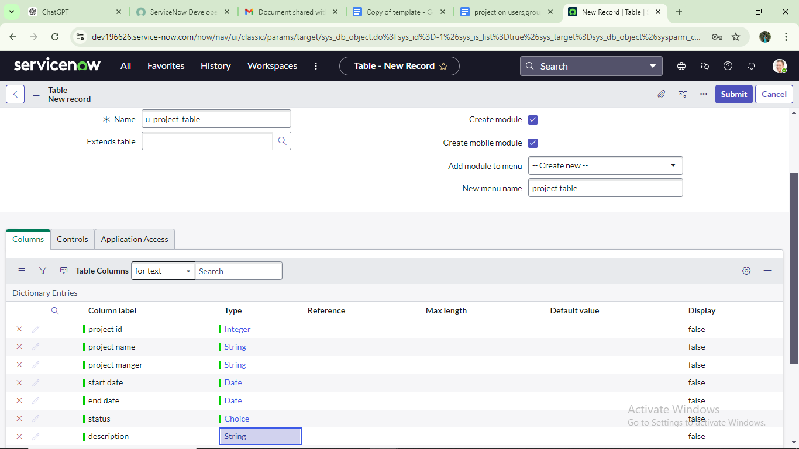

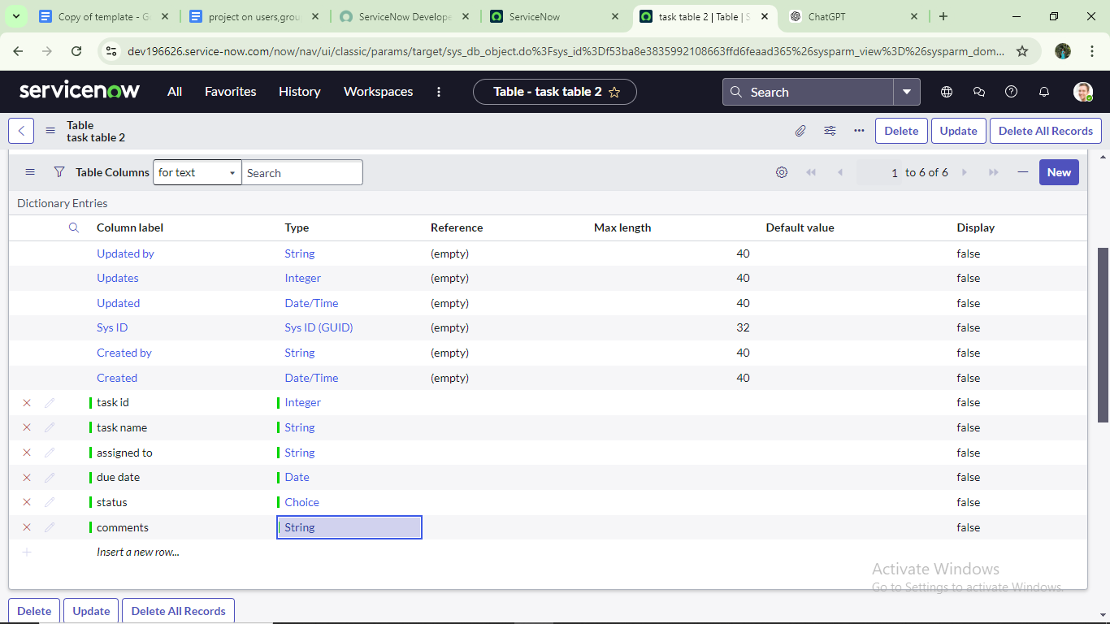

**👥 Add Users to a Group in ServiceNow**

1. **Log in to ServiceNow.**
2. In the left-hand navigation panel, click **“All”** to expand all modules.
3. In the filter navigator, type **“Groups”** and press Enter.
4. Under **System Security**, click on **“Groups.”**
5. From the list of groups, find and click on the **“Project Team”** group.
6. Scroll down to the **Group Members** section (usually a related list at the bottom of the group record).
7. Click the **“Edit”** button in the Group Members section.
8. In the pop-up window:
   * Search for and select **Alice P**
   * Search for and select **Bob P**
   * Use the right arrow (→) to move them to the **Selected** list

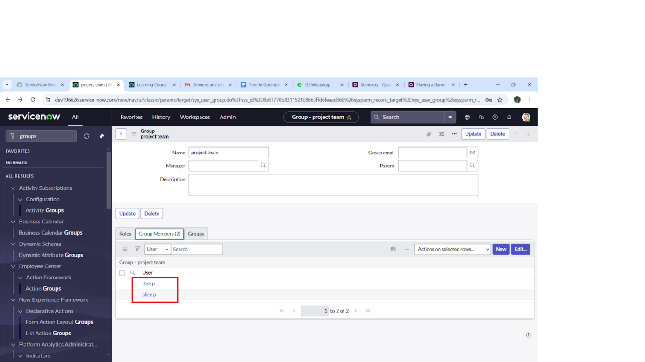

**🎯 Assign Roles to Alice in ServiceNow**

1. **Log in to ServiceNow.**
2. In the left-hand navigation pane, click **“All”** to expand the modules.
3. In the filter navigator, type **“Users”** and press Enter.
4. From the list, find and select the **Project Manager** user (assuming this is Alice’s user record).
5. Scroll to the **Roles** related list on the user’s form.
6. Click **“Edit”** in the Roles section.
7. In the pop-up, select **Project Member** role and move it to the selected list. Click **Save**.
8. Again, click **“Edit”** to add more roles.
9. Search for and add the following roles:
   * u_project_table
   * u_task_table
10. Click **Save** to update the roles.
11. Finally, click **Update** on the user form to save all changes.

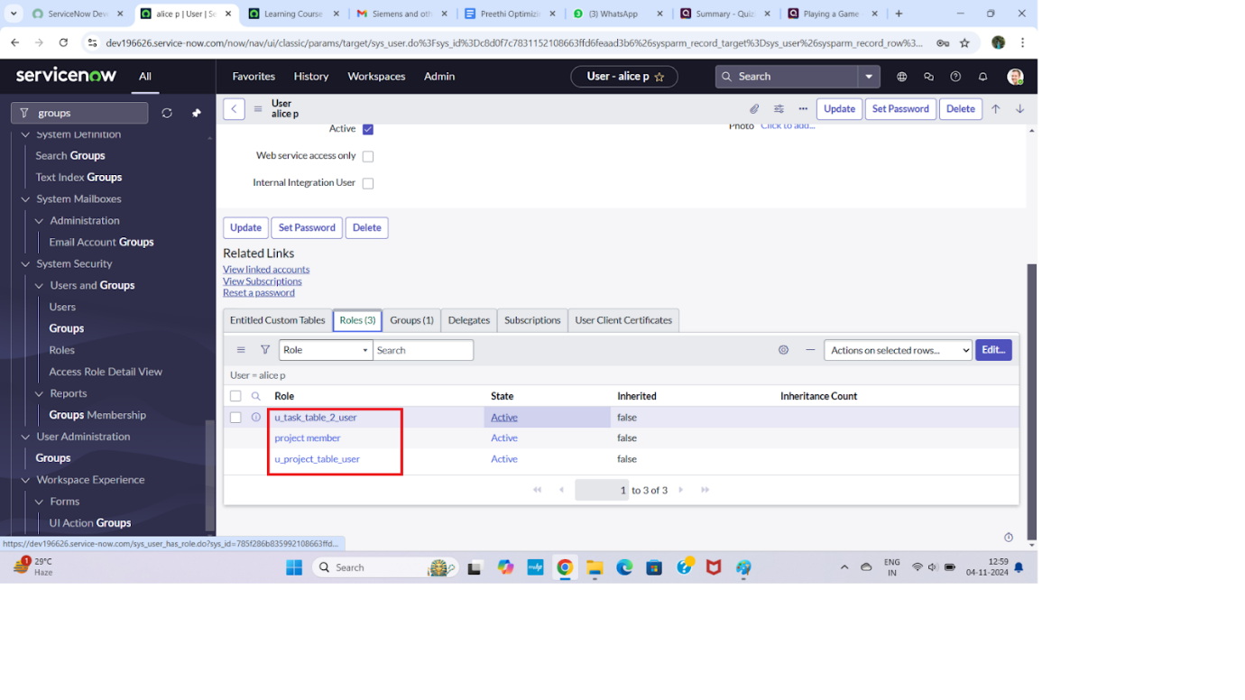

**✅ How to Assign Roles to Bob and Test Access in ServiceNow**

**🔹 Step 1: Open ServiceNow & Search for the User**

1. Log into **ServiceNow**.
2. In the **Application Navigator**, click on **All** or use the search bar.
3. Type and select: **Users** (under the **User Administration** section).

**🔹 Step 2: Find and Open Bob's User Record**

1. In the list of users, search for **Bob P** (or however the username is listed).
2. Click on the record to open **Bob's user profile**.

**🔹 Step 3: Assign the Role**

1. Scroll down to the **Roles** related list.
2. Click **Edit** (next to the Roles section).
3. In the **Collection box**, search and select the role(s):
   * team_member
   * Any **table-specific role** needed (e.g., one tied to Task Table2).
4. Click **Add →** and then **Save** or **Update**.

**🔹 Step 4: Impersonate Bob to Test Access**

1. Click on your **profile icon** (top-right corner of the screen).
2. Choose **Impersonate User** → Search and select **Bob P**.
3. You are now viewing ServiceNow as Bob.

**🔹 Step 5: Verify Access**

1. In the Application Navigator (while impersonating Bob), search for:
   * **Task Table2**
2. If Bob has the correct roles, **Task Table2** should now be visible and accessible.

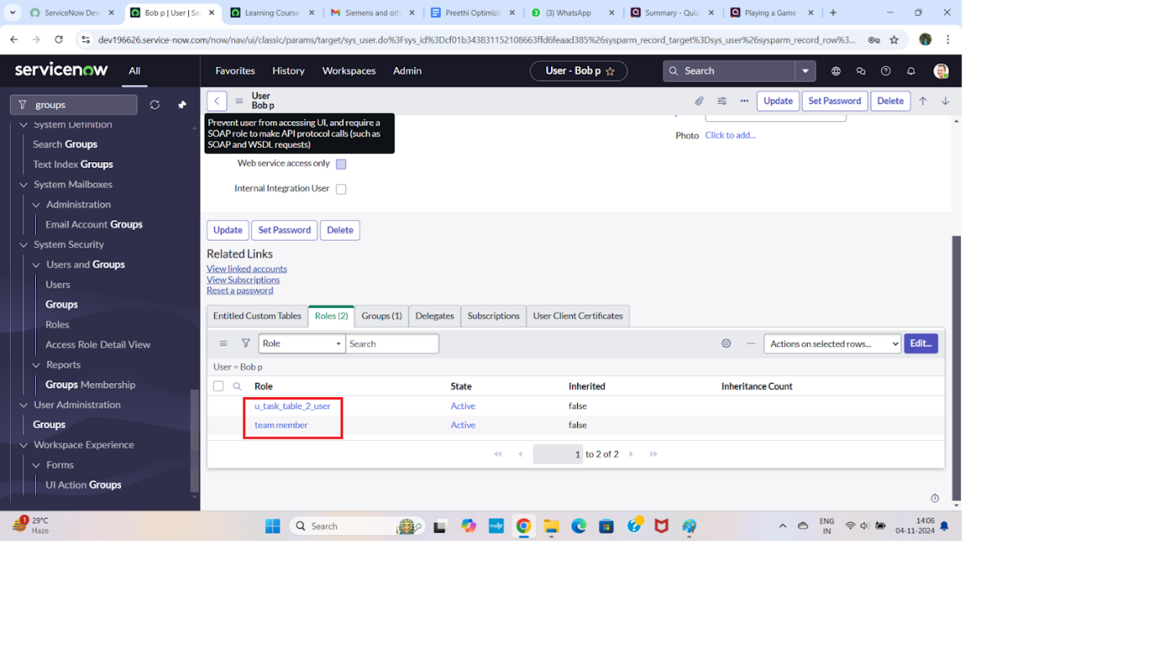

**✅ Assign Table Access to an Application (Humanized Instructions)**

When you create a new table in ServiceNow (or a similar system), an **Application** and a **Module** are automatically created for that table. Follow these steps to update access roles:

**1. Create the Table**

* When you create a new table (e.g., Project or Task Table 2), the system will automatically:
  + Create an **Application** associated with that table.
  + Add a **Module** under that application in the navigator.

**2. Find the Application in the Navigator**

* Go to the **Application Navigator**.
* Search for your table’s application:
  + Type: Project → select the **Project Table Application**.
  + Type: Task Table 2 → select the **Task Table 2 Application**.

**3. Edit the Application Module**

* Click on the **Edit Module** or **Edit Application** (depending on what shows up).
* You’ll now be in the application/module settings.

**4. Assign Roles**

* For the **Project Table Application**:
  + Add the role: project_member
* For the **Task Table 2 Application**:
  + Add both roles: project_member and team_member

**🔒 Why Assign Roles?**

Assigning roles ensures only users with the right permissions can access the application and view/edit data related to those tables.

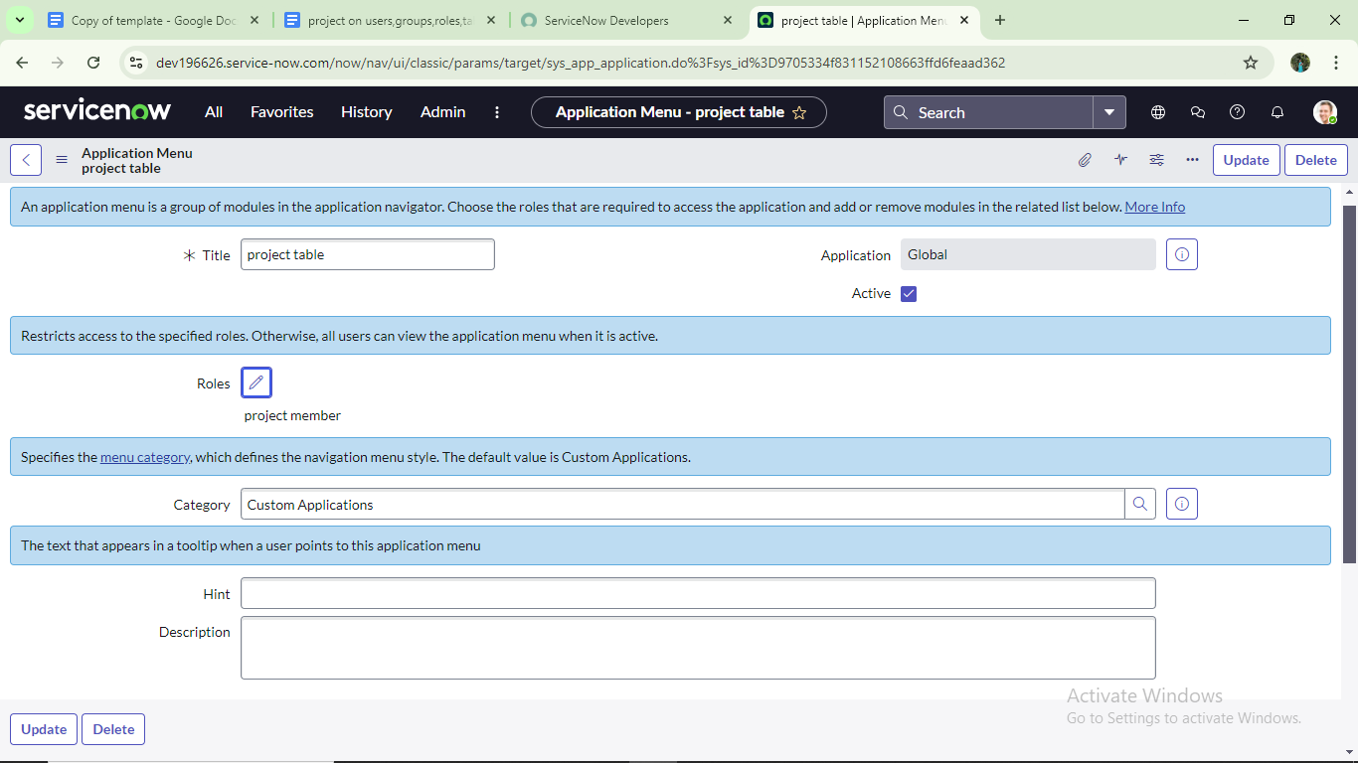



**✅ Step 1: Open ServiceNow & Navigate to ACL**

1. **Login** to your **ServiceNow** instance.
2. In the **Application Navigator** (left sidebar), click on **All**, or simply use the search bar.
3. Search for:
4. ACL
5. Under **System Security**, click on:  
   **Access Control (ACL)**

**🔒 Step 2: Elevate Your Role (if required)**

1. Click on the **profile icon** (top right corner).
2. Choose **Elevate Roles**.
3. Check the box for:
   * security_admin
4. Click **OK** to confirm elevation.

⚠️ Elevating to security_admin is required to create or modify ACLs.

**➕ Step 3: Create a New ACL**

1. On the **Access Control (ACL)** list page, click the **New** button.

**📝 Step 4: Fill in ACL Details**

1. Fill in the necessary fields. Here's an example:

| **Field** | **Value** |
| --- | --- |
| **Type** | Record |
| **Operation** | Read / Write / Create / Delete (choose as needed) |
| **Name** | Select the Table (e.g., task_table2) |
| **Requires Role** | Select the role(s) required (e.g., team_member, project_member) |
| **Condition** | Add optional conditions for access (e.g., Active is true) |
| **Script** | (Optional) Add custom script logic to evaluate access |

1. Once everything is filled out, click **Submit**.

**✅ After Creating a New ACL (continued):**

1. Scroll down to the **Requires Role** related list.
2. **Double-click** on the empty row that says:  
   "Insert a new row..."
3. In the popup or inline form:
   * **Table**: Select the relevant table (e.g., task_table2)
   * **Role**: Select team_member
4. Click **Submit** (or checkmark ✓ if inline).

**🔁 Step: Create 4 ACLs for Specific Fields**

Repeat the ACL creation steps for each of the following **fields** (assuming these are on the same table, e.g., task_table2):

| **Field Name** | **Operation** | **Role(s) Required** |
| --- | --- | --- |
| short_description | Read | team_member |
| state | Write | team_member |
| assigned_to | Read | project_member |
| description | Write | project_member |

**🔄 How to Do It:**

For **each field**, follow these steps:

1. Go to **Access Control (ACL)** → Click **New**.
2. Set **Type**: record
3. Set **Operation**: (Read / Write as needed)
4. Set **Name**: Select the **Table** (e.g., task_table2) → then choose the **Field** (e.g., short_description)
5. Scroll down to **Requires Role** → Insert the required role (team_member or project_member)
6. Click **Submit**

**✅ Step 1: Impersonate the User (Bob)**

1. Click on your **profile icon** in the **top-right corner** of the screen.
2. Choose **Impersonate User** from the dropdown menu.
3. In the user search box, type and select:  
   **Bob** (or Bob P, depending on the full name).
4. You are now logged in as **Bob**.

**✅ Step 2: Navigate to the Application**

1. In the **Application Navigator** (left menu), click **All** or use the search bar.
2. Search for:  
   **Task Table2** (the custom app/module you created).
3. Click to open the **Task Table2** list or form.

**✅ Step 3: Verify Field-Level ACLs**

1. Open any record from the **Task Table2** list.
2. Check the following fields:
   * **Comment**: ✅ Should be **editable**.
   * **Status**: ✅ Should be **editable**.

💡 If Bob can successfully edit these fields, it confirms that the ACLs and roles (team_member, project_member) are correctly applied.

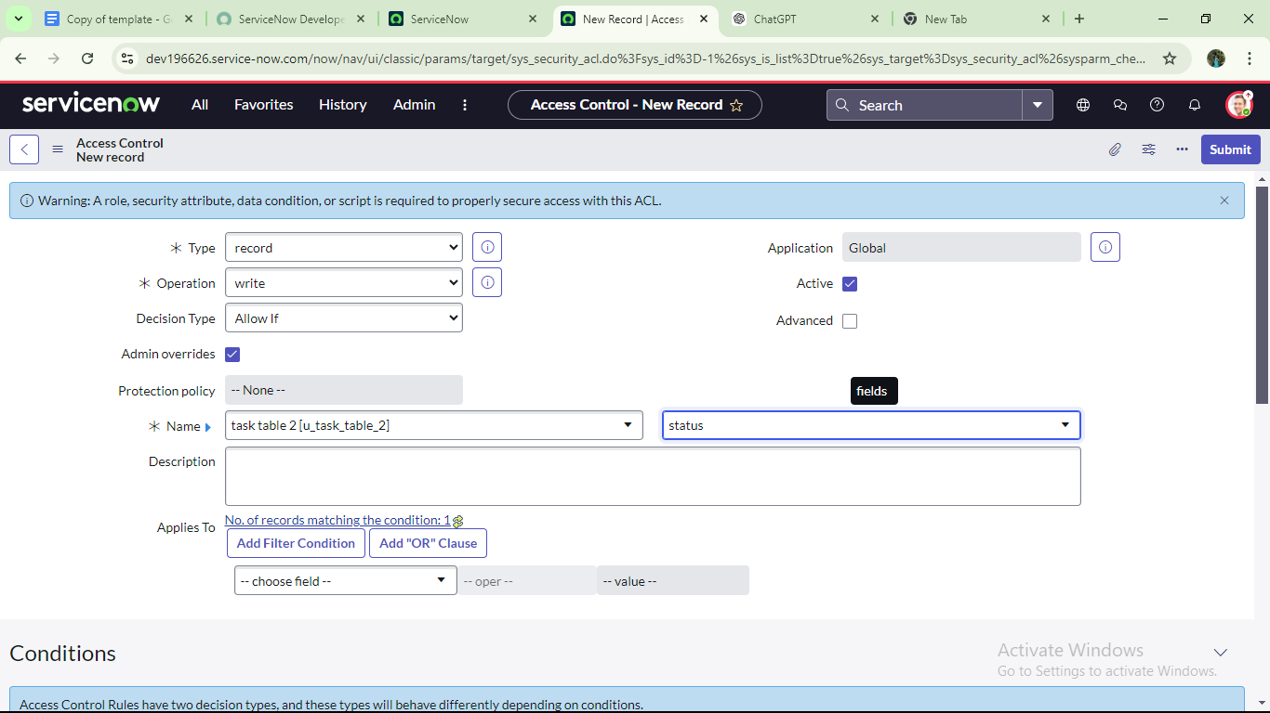

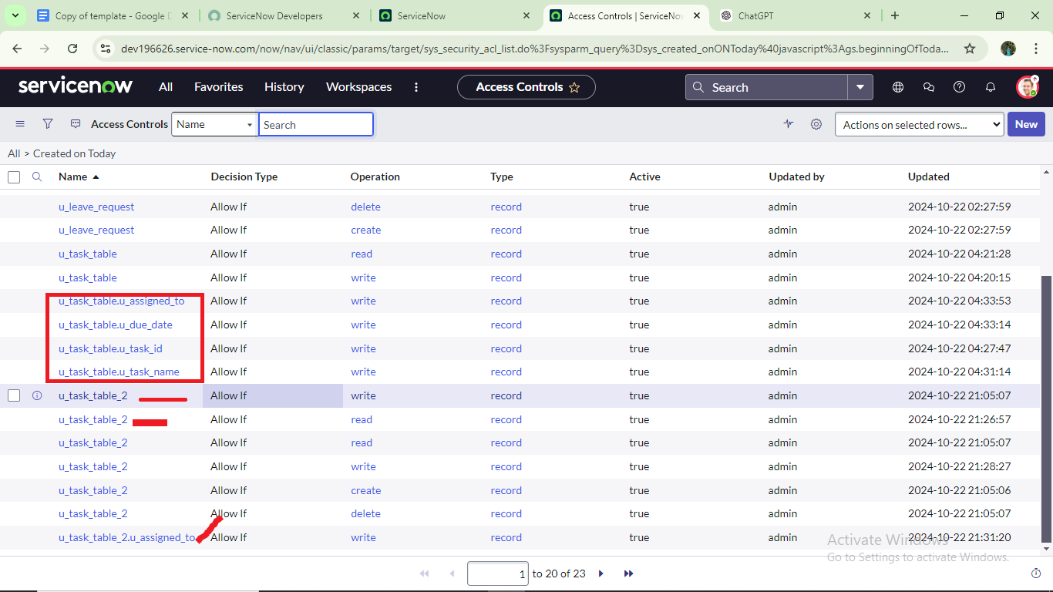

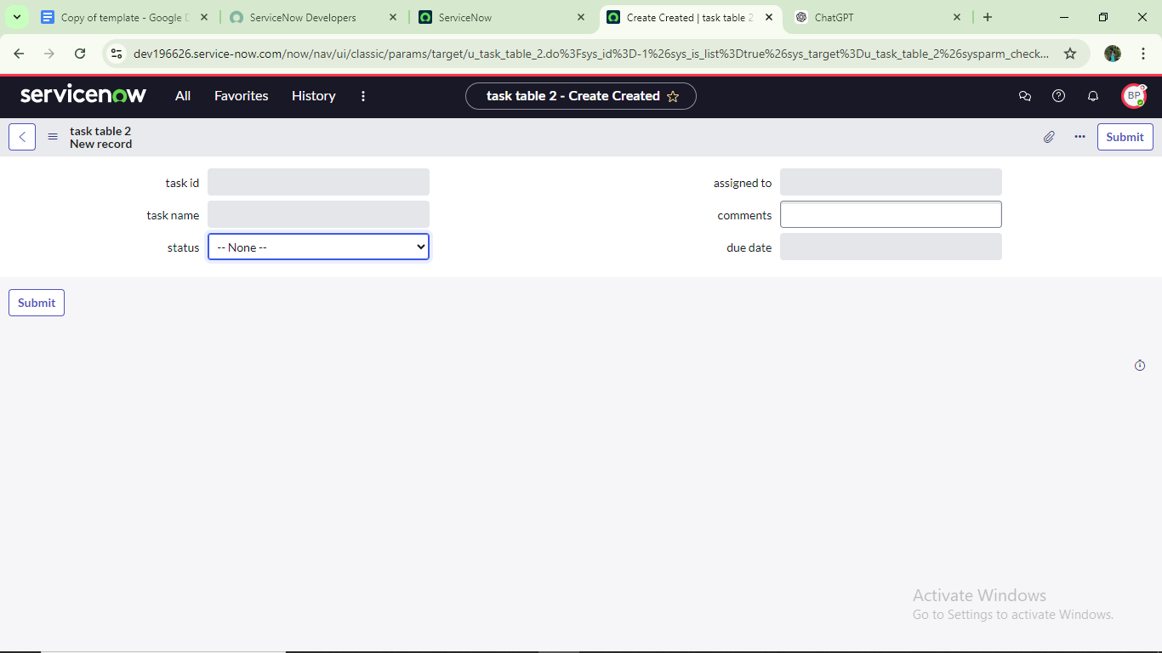

**🔁 Create a Flow to Assign Operations Ticket to a Group in ServiceNow**

**✅ Step 1: Open Flow Designer**

1. Log into **ServiceNow**.
2. In the **Application Navigator**:
   * Click on **All** or use the search bar.
   * Type: Flow Designer
3. Click on **Flow Designer** under the **Process Automation** section.

**✅ Step 2: Create a New Flow**

1. Once Flow Designer opens, click the **New** button (top right).
2. A popup will appear for flow details:
   * **Name**:
   * task table
   * **Application**:
   * Global
3. Click **Submit** (or **Next**, depending on your version).
4. Then click **"Click to continue"** or **"Create Flow"** to start building the flow.

**✅ Step 3: Define the Trigger**

1. Under **Trigger**, click **+ Add Trigger**.
2. Choose:
   * **Table**: Task Table (or your custom table like task_table2)
   * **Trigger Conditions**:
     + **Created** or **Updated** (depending on your use case)
3. Click **Done**.

**✅ Step 4: Add Action – Assign to Group**

1. Click **+ Add Action**
2. Choose:

* **ServiceNow Core** → **Update Record**

1. Set the following:

* **Table**: Task Table
* **Record**: Use data pill (e.g., Trigger → Record)
* **Fields to Update**:
  + **Assignment Group** → Select the group (e.g., Operations or your custom group)

1. Click **Done**.

**✅ Step 5: Save & Activate**

1. Click **Save**.
2. Then click **Activate** to turn on the flow.

**▶️ Step: Add a Trigger for Record Creation with Specific Conditions**

**✅ Step 1: Add a Trigger**

1. In the **Flow Designer**, click on **“+ Add Trigger”** (if you haven't already).

**✅ Step 2: Select Trigger Type**

1. In the trigger selection window:
   * Search for:
   * Create Record
   * Select the trigger type: **Created Record**

**✅ Step 3: Configure the Trigger**

1. Set the following values:
   * **Table**:
   * task table

**✅ Step 4: Add Trigger Conditions**

1. Under **Conditions**, click **+ Add Condition** three times and fill them out as follows:

| **Field** | **Operator** | **Value** |
| --- | --- | --- |
| Status | is | In Progress |
| Comments | is | feedback |
| Assigned to | is | Bob |

💡 Use the field picker to ensure correct field names, and select "Bob" from the user list for Assigned to.

**✅ Step 5: Finish Trigger Setup**

1. Click **Done** to save the trigger configuration.

✅ **Trigger Set!**  
Now, this flow will **run automatically** when a new record is created in the task table **with the following conditions**:

* Status = *In Progress*
* Comments = *feedback*
* Assigned to = *Bob*

**🔧 Step: Add an Action to Update the Record in Flow Designer**

**✅ Step 1: Add an Action**

1. After setting up the trigger, click on **“+ Add Action”** below it.

**✅ Step 2: Select Action Type**

1. In the action selection window:
   * Search for:
   * Update Record
   * Click on **Update Record** (under **ServiceNow Core**).

**✅ Step 3: Configure the Action**

1. In the **Record** field:
   * From the **Data Panel** on the right side, expand the **Trigger** section.
   * Drag the **Record** data pill into the **Record** field of the action.
2. The **Table** will be auto-filled based on the record (e.g., task table).

**✅ Step 4: Set Fields to Update**

1. Under **Fields to update**, click **+ Add Field**.
2. Set the following:
   * **Field**: Status
   * **Value**: Completed (select from dropdown if available)

**✅ Step 5: Save the Action**

1. Click **Done** to complete this action setup.

**✅ Final Verification: Check If Status Was Updated**

**🔍 Step 9: Search for the Task Table**

1. In the **Application Navigator** (left-hand side):
   * Click **All** or use the search bar.
   * Type:
   * task table
   * Select the relevant **Task Table** module from the results (this should open the list of records).

**📋 Step 10: Verify Record Update**

1. Look through the list of records or use filters to find the one that matches:
   * **Status**: *In Progress*
   * **Comments**: *feedback*
   * **Assigned to**: *Bob*
2. Open the record.
3. ✅ Confirm that the **Status field** has been **automatically updated to "Completed"** — this means your **flow ran successfully**!

🎉 **Flow Verified!**  
You’ve now built and tested a working **Flow in ServiceNow** that:

* Triggers on record creation with specific conditions.
* Automatically updates the record’s status field.

**✅ Step 11–13: Approve a Request from My Approvals (as Alice)**

**🔍 Step 11: Open "My Approvals"**

1. In the **Application Navigator** (left panel):
   * Click **All** or use the search bar.
   * Type:
   * My Approvals
2. Under the **Service Desk** section, click on:  
   **My Approvals**

**👤 Step 12: View Alice P’s Approval Requests**

1. Ensure you’re logged in **as Alice P** or impersonating her.

If not already impersonating, click your profile icon > **Impersonate User** > select **Alice P**.

1. You’ll now see a list of approval records assigned to Alice.

**🟢 Step 13: Approve the Request**

1. Locate the relevant approval request in the list.
2. Right-click on the **Requested** status field of that record.
3. From the context menu, click on:  
   **Approve**

